# **AI Vendor Evaluation Framework**

Version: [Version Number]

Last Updated: [Date]

Review Cycle: Quarterly

## **1. Pre-Evaluation Checklist**

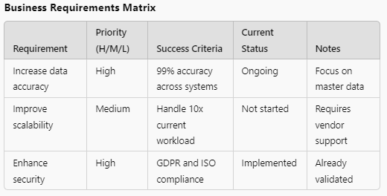

### **Business Requirements Matrix**

| **Requirement** | **Priority** | **Success Criteria** | **Current Status** | **Notes** |
| --- | --- | --- | --- | --- |
| [Requirement 1] | [H/M/L] | [Measurable Outcome] | [Status] | [Notes] |

### **Stakeholder Registry**

| Department | Representative | Role | Requirements | Sign-off Status |
| --- | --- | --- | --- | --- |
| [Dept] | [Name] | [Role] | [Key Requirements] | [Status] |

### **Resource Allocation**

| **Resource Type** | **Allocated** | **Required** | **Gap** | **Action Plan** |
| --- | --- | --- | --- | --- |
| [Resource] | [Current] | [Needed] | [Gap] | [Plan] |

## **2. Vendor Assessment Template**

### **Capability Evaluation Matrix**

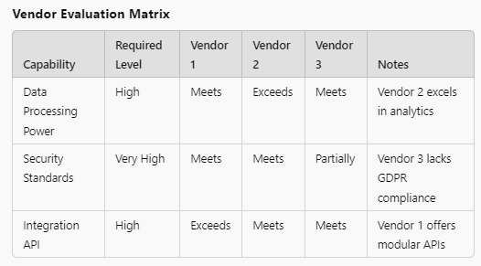

| **Capability** | **Required Level** | **Vendor 1** | **Vendor 2** | **Vendor 3** | **Notes** |
| --- | --- | --- | --- | --- | --- |
| [Capability] | [Level] | [Score] | [Score] | [Score] | [Notes] |

### **Technical Assessment Checklist**

* Architecture Review
* Security Assessment
* Performance Testing
* Integration Capabilities
* Scalability Assessment

### **Reference Check Template**

| **Reference Area** | **Questions** | **Responses** | **Red Flags** |
| --- | --- | --- | --- |
| [Area] | [Key Questions] | [Findings] | [Issues] |

## **3. Cost Analysis Framework**

### **Direct Cost Tracking**

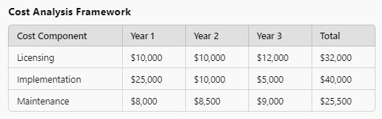

| **Cost Component** | **Year 1** | **Year 2** | **Year 3** | **Total** |
| --- | --- | --- | --- | --- |
| Licensing | [$] | [$] | [$] | [$] |
| Implementation | [$] | [$] | [$] | [$] |
| Training | [$] | [$] | [$] | [$] |

### **Hidden Cost Identification**

| **Cost Type** | **Probability** | **Impact** | **Mitigation Strategy** |
| --- | --- | --- | --- |
| [Cost] | [H/M/L] | [$] | [Strategy] |

## **4. Contract & Risk Management**

### **Contract Requirements Checklist**

* Service Level Agreements
* Performance Metrics
* Exit Clauses
* Data Ownership
* Support Terms

### **Risk Assessment Matrix**

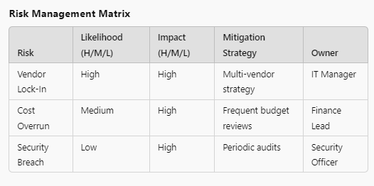

| **Risk** | **Likelihood** | **Impact** | **Mitigation** | **Owner** |
| --- | --- | --- | --- | --- |
| [Risk] | [H/M/L] | [H/M/L] | [Strategy] | [Name] |

## **5. Ongoing Management Dashboard**

### **Performance Tracking**

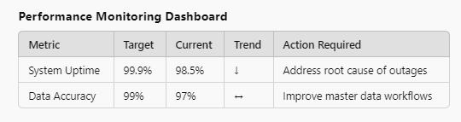

| **Metric** | **Target** | **Current** | **Trend** | **Action Required** |
| --- | --- | --- | --- | --- |
| [KPI] | [Target] | [Actual] | [↑/↓] | [Action] |

### **Review Schedule**

| **Review Type** | **Frequency** | **Last Review** | **Next Review** | **Owner** |
| --- | --- | --- | --- | --- |
| [Type] | [Frequency] | [Date] | [Date] | [Name] |

### **Market Intelligence Log**

| **Date** | **Development** | **Impact** | **Action Required** |
| --- | --- | --- | --- |
| [Date] | [Event] | [Impact] | [Action] |

## **Framework Maintenance**

### **Version Control**

| **Version** | **Date** | **Changes** | **Author** |
| --- | --- | --- | --- |
| [Version] | [Date] | [Changes] | [Name] |

### **Improvement Log**

| **Date** | **Suggestion** | **Status** | **Implementation** |
| --- | --- | --- | --- |
| [Date] | [Suggestion] | [Status] | [Plan] |

## **Instructions for Use**

1. Complete all sections progressively
2. Update regularly based on review cycle
3. Maintain version control
4. Document all decisions and changes
5. Review and adjust metrics quarterly
6. Share updates with stakeholders

## **Review Process**

* Quarterly framework effectiveness review
* Monthly performance metric updates
* Weekly risk assessment updates
* Ad-hoc updates as needed